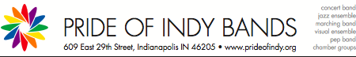

2015 Lesbian and Gay Band Association

Conference Scholarship Application

For Pride of Indy Bands

Name: ____________________________________ Instrument: _________________________________

DOB: _______/_________/_________ Email: ________________________________________

Approx. Annual Income: ___________________ First Conference? Y/N

The reason I wish to attend this conference is:

I plan to volunteer at the following POI Events during 2015: (Circle all that apply)

Spring Concert (4/7) Dragnado (4/23)

Pride Skate (6/7) Anniversary Concert (6/9)

Pride Festival (6/13) Garfield Park Concert (TBD)

Time Warp (TBD) Holiday Concert (TBD)

When did you join Pride of Indy: _______________________________________________________



In your own words, please tell us your band story, I.E. What made you join, what has made you stay, and what the Pride of Indy Bands means to you: